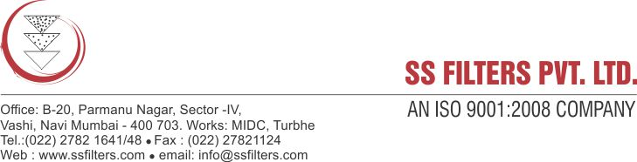
Specification Sheet
WOUND FILTER CARTRIDGE
(POLYPROPYLENE/ MICROGLASSFIBER/ COTTON)
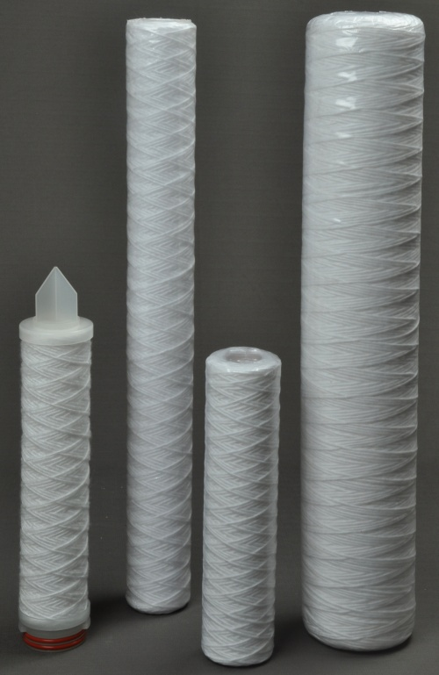
SS Filters Wound Filter Cartridges are manufactured using a high speed, continuous wind process which creates a superior one-piece filter with hundreds of diamond shaped tunnels that get progressively smaller from the outer diameter to the core. Finer particles are progressively trapped as fluid travels to the centre of the filter allowing for much greater retention capacity than straight surface filter media of same dimensions & porosity.

The double O-ring sealing system ensures positive sealing of the filter cartridge within the housing and virtually eliminates and potential for bypass. The all polypropylene construction provides excellent chemical compatibility in a wide variety of process streams.

PP Filter Cartridges are available in a wide range of lengths and micron sizes. Two sizes are available- Standard and Jumbo as per your flow rate and volume requirements.

FEATURES & BENEFITS:
- True Depth filtration
- High Solids holding capacity
- Wide chemical compatibility
- A broad range of media and center core options provide excellent compatibility with a variety of fluids.
- Removal ratings from 1 to 20μm
- High efficiency but low in price for equipment installation & cost saving
- Fits into most standard housings
- Graded pore structure for efficient removal of a wide range of particle size

PRODUCT SPECIFICATION
Micron Rating | 1, 5, 10, 20 µ
Length | 10", 20", 30", 40"
Inner Dia-Standard size  Inner Dia- Jumbo size | 28 mm  28 mm
Outer Dia-Standard size  Outer Dia- Jumbo size | 60-62 mm  105-110 mm
Effective Surface area per 10" cartridge element | 3.5 sq. feet

CONSTRUCTION:
- Filter media: 100% Polypropylene fiber / Microglassfiber/ Cotton
- Support media: Polypropylene fiber
- Inner core: Polypropylene cage/ Stainless steel for cotton wound
- End Caps: Polypropylene if code 7 type
- ‘O’ Rings: Silicone/ EPDM/ Viton

CONFIGURATION:

- Double open end type (DOE Type)
- Code 7S (226 ‘O’ Ring design/ Bayonet or fin)

APPLICATIONS:

- Organic Acids, Alkalis, Solvents
- Chemical industries
- Food & Beverage
- Electronic Industry
- Potable liquids, oils
- Fishing industry
- Cosmetic industry
- Solar heating system
- Petrochemical industry
- Water based solutions
- Reverse osmosis pre treatment

