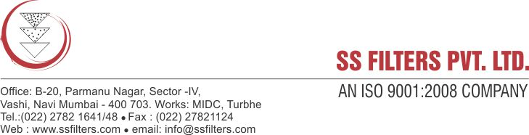
Specification Sheet
POLYPROPYLENE PLEATED FILTER CARTRIDGE
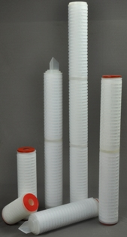

Polypropylene pleated filter cartridges have been designed as an effective membrane prefilters and as final polishing filters for many liquid processing applications. PP Filter cartridges are double layered filters. The graded porosity design removes particles in sequence such as larger particles by the more open outer layers and the smaller particles by the tighter inner layers. The outer layer acts as the prefilter while the inner layers provide the rating at the specified pore size. This efficiently spreads the contaminants throughout the media matrix resulting in superior contaminant holding capacity, lifetime & pressure drop as compared to other media cartridges.

FEATURES & BENEFITS:

- Very good for pre filtration & Clarification of fluids
- Graded porosity polypropylene Media.
- 100% PP construction, wide chemical compatibility.
- Consistent & good flow rates.
- Biologically safe
- No fiber migration
- FDA approved
- Thermally welded construction
- End connections to fit all standard housings

Micron Rating | 0.2 ,0.45 ,1, 5, 10, 20µ
Length | 5", 10" , 20" , 30" , 40"
Inner Dia | Approx. 28mm
Outer Dia | Approx. 65 - 69mm
Effective surface area per 10” element | 7.5 sq. feet (0.65 msq.)
Max operating temperature | 80˚C (176˚ F)
Sterilization  Autoclave  Hot water | 121˚C, 30 min, 10 times 80˚C, 30 min, 30 times
Max differential pressure | 5.5 bar (80 psi)@ 21˚C
PRODUCT SPECIFICATIONS

CONSTRUCTION:

- Filter media: 100% Polypropylene fiber
- Support media: Polypropylene fiber
- MOC: Polypropylene
- ‘O’ Ring/ Gaskets: Silicone/ EPDM/ Viton

CONFIGURATION:

- Double open end type (DOE Type)
- Code 7 (226 ‘O’ Ring design/ Bayonet or fin)
- Code 3S (222 ‘O’ Ring design/ Bayonet or fin)

APPLICATIONS:

Food & beverage: Bottled water, beers, wines, flavours, polishing lines, clarification
Pharmaceutical: Membrane pre-filtration, opthalmics, oral medications, serum
Fine chemicals: Polymers, photoresists, acids, bases, solvents
Electronics: High purity water, photo resists, acids, etch solutions
Cosmetics: Alcohol, creams, lotions, essential oils, mouthwashes
Metal finishing: Plating solutions, wash solutions, paints, resins, varnishes
Water treatment: Potable water, resin trap, pre/ post UV, membrane protection

CONFIGURATIONS

